**HKID Card Identification SDK-Android Documentation**

**Jun 2019**

Version 1.0



© 2019 TransUnion LLC  
All Rights Reserved

No part of this publication may be reproduced or distributed in any form or by any means, electronic or otherwise, now known or hereafter developed, including, but not limited to, the Internet, without the explicit prior written consent from TransUnion LLC.

Requests for permission to reproduce or distribute any part of, or all of, this publication should be mailed to:

Law Department  
TransUnion  
555 West Adams   
Chicago, Illinois 60661

The “T” logo, TransUnion, and other trademarks, service marks, and logos (the “Trademarks”) used in this publication are registered or unregistered Trademarks of TransUnion LLC or their respective owners. Trademarks may not be used for any purpose whatsoever without the express written permission of the Trademark owner.

[transunion.com](http://www.transunion.com/)

**Document History**

|  |  |  |  |
| --- | --- | --- | --- |
| **Version** | **Description** | **Prepared By** | **Date** |
| 1.0 | Initial version | TU | Jun 26, 2019 |
|  |  |  |  |
|  |  |  |  |
|  |  |  |  |
|  |  |  |  |
|  |  |  |  |
|  |  |  |  |
|  |  |  |  |
|  |  |  |  |
|  |  |  |  |

Table of Contents

1. Introduction 5

1.1. Objective 5

1.2. Version Support 5

2. SDK Integration 5

2.1. Integration Steps 5

3. SDK Call 6

3.1. New HKID Card (2018) 6

3.2. Old HKID Card (2003) 6

3.3. Return Value Description 7

4. SDK Usage 7

4.1. Example of using the SDK 7

# Introduction

## Objective

Describe the details and usage of HKID Card Identification SDK for third parties.

## Version Support

Android 5.0 or above.

# SDK Integration

## Integration Steps

* Add the following to project’s libs folder



* Add the following to project’s jniLibs folder



* Add the following settings to project’s build.gradle file

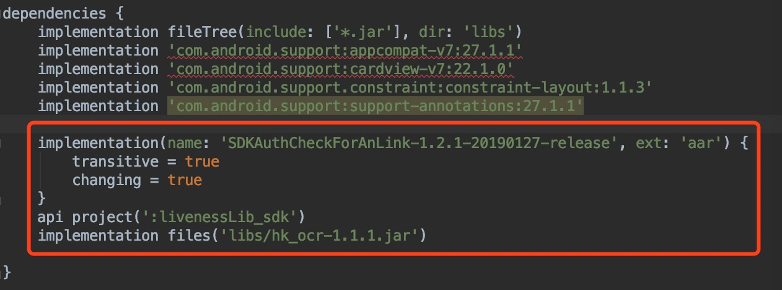

* Add permission required and Activity settings in AndroidManifest.xml file

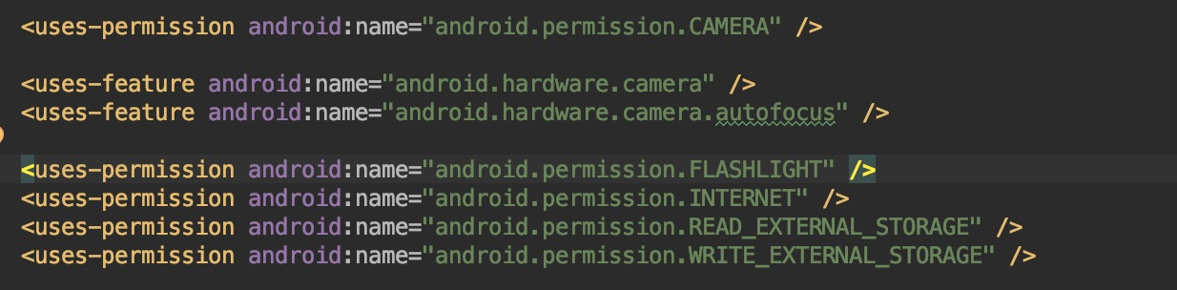

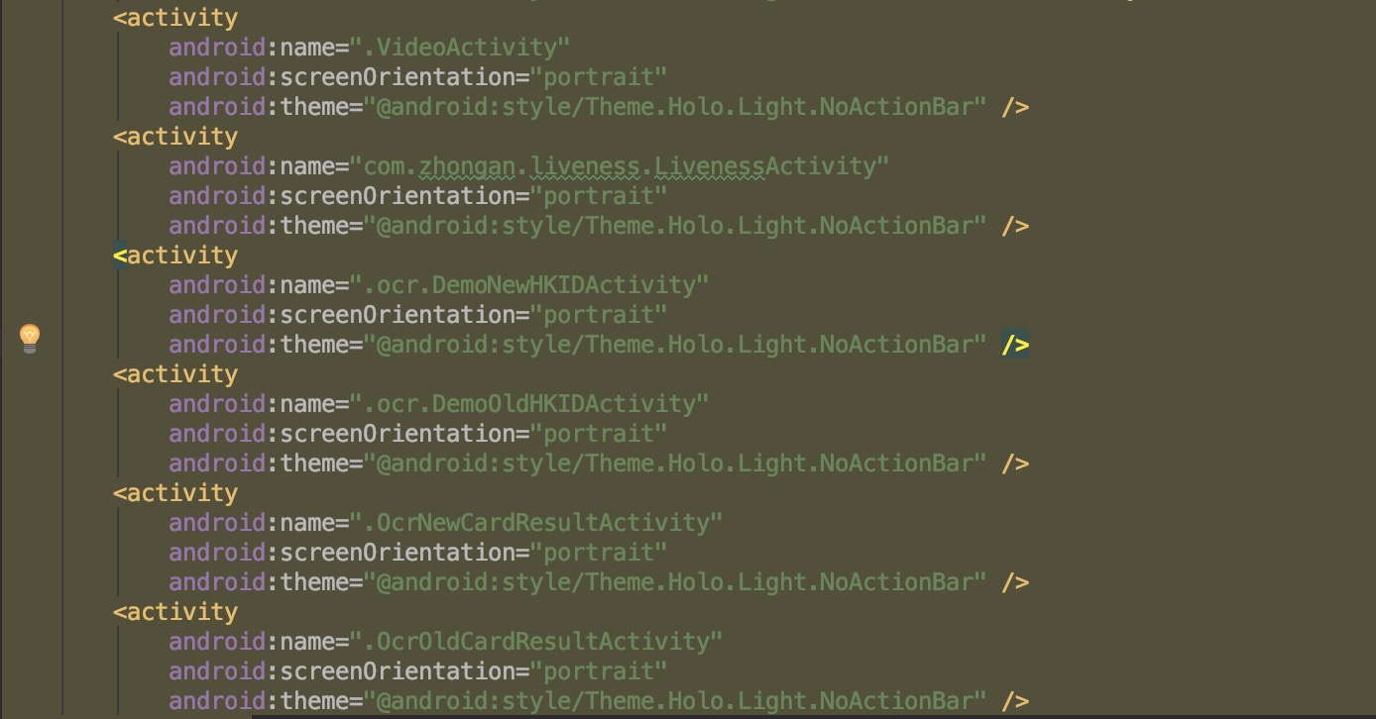

# SDK Call

## New HKID Card (2018)

* Use the following to start the page of scanning ID card

OcrSDKManager.getInstance().startDemoNewIdentifyIDCard(App Activity.this,true);

## Old HKID Card (2003)

* Use the following to start the page of scanning ID card

OcrSDKManager.getInstance().startDemoOldIdentifyIDCard(App Activity.this,true);

## Return Value Description

public static final int CALLBACKDATA_SUCCESS; // Detection success

public static final int CALLBACKDATA_FAIL; // Detection failed

public static final int CALLBACKDATA_CANCEL; // User cancel detection

public static final int CALLBACKDATA_EXCEED; // Detection time exceeded

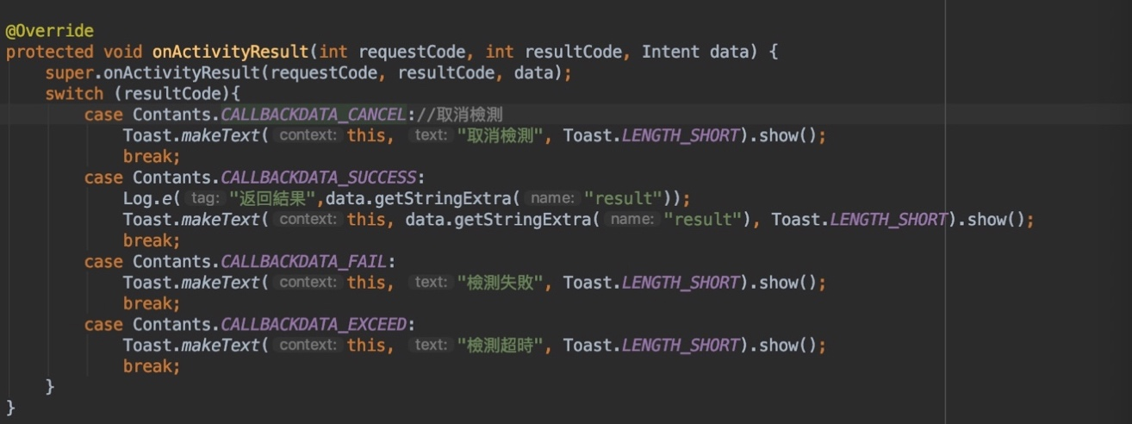

# SDK Usage

## Example of using the SDK

Refer to the code of the Sample project provided